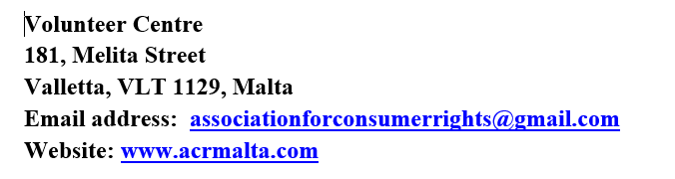

**Association for Consumer Rights (Malta)**

**Membership/Life Membership**

**SURNAME/KUNJOM:______________________________________________________**

**CHRISTIAN NAMES/ISEM:__________________________________________________**

**ADDRESS/INDIRIZZ:**

**________________________________________________________________________**

**________________________________________________________________________**

**TEL:_____________________________________________________________________**

**EMAIL :__________________________________________________________________**

**DATE OF BIRTH/DATA TAT-TWELID:___________________________________________**

**NATIONALITY/NAZZJONALITA:_______________________________________________**

**Mr./Ms.:_________________________________________________________________**

**SIGNATURE/FIRMA________________________________________________________**

**ID Number:_______________________________________________________________**

**Annual Membership Fee (Five (5) Euro) _______________________________________**

**Life Membership Fee (twenty (21) Euro) ___________________________________**

**To be returned by post with a cheque made out to “ACR Malta” to the following address:**

**ACR Malta**

**c/o The Orchid Flat 1A BlkA,**

**Triq Giuseppe Cali’**

**Lija LJA 1433, Malta**